Version Control System(VCS)

Git:

* Git Hub
* Git Lab
* Bit Bucket
* aws codecommit

SBN:

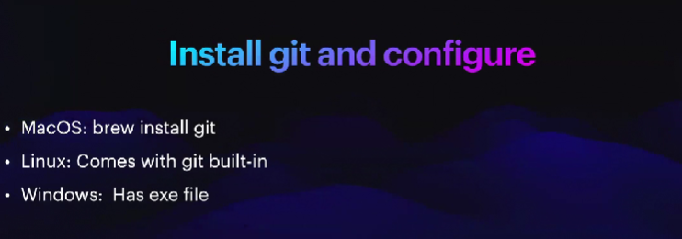

Installing Command for different operating system.

Why Git:

Deploy, add, commit, git push,

Every single open source project a contribution a minimum requirement : “Certain rule should be Maintain”

* Commit
* Formatting
* File formet

How to Contribute in a open source project :

Git Install Command: brew install git

Git init --help

WE SHOULD ANALYSIS CLID TOOL

“GIT INIT”

“ZFSH” PLUGIN FOR BETTER LOOKING IN GIT.

Z shell. For colouring

ls –a for showing hidden file.

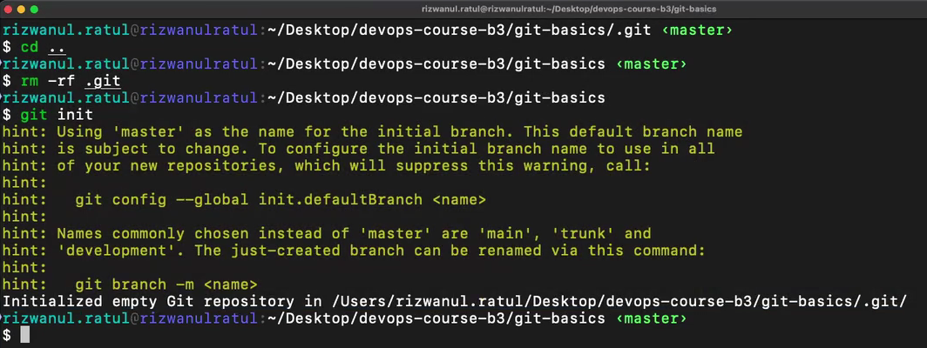

Cd ..

Rm –rf .git

Git init

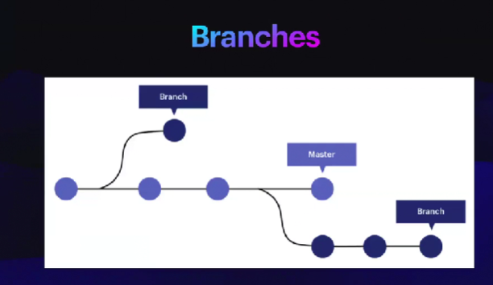

Git status

Git add “file name” / git add .

Git commit –m “commit message”

Developer will commit to the RAPO. But DevOps should force maintain rule and regulation.

Code Quality should check.

Unnecessary code. Pipeline integration, unnecessary return.

“Git log” for showing all commit

“Self hosted git lab”

Production server a git pull/push deya host kora bad practice.